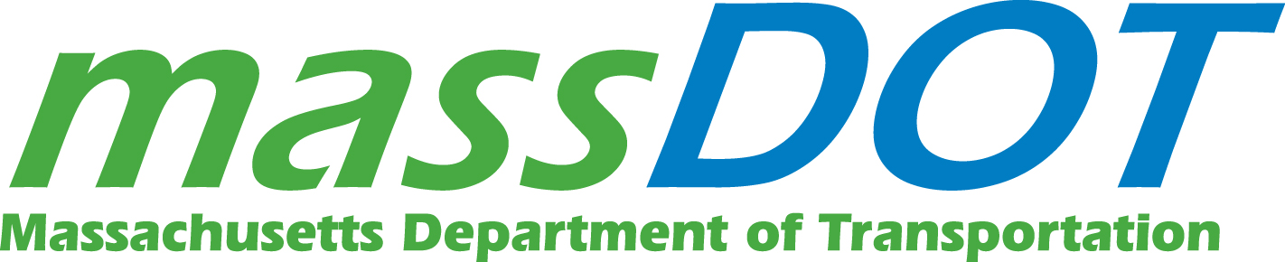
MASSACHUSETTS DEPARTMENT OF TRANSPORTATION (MassDOT)
HIGHWAY DIVISION
10 PARK PLAZA
BOSTON, MA 02116

REQUEST FOR PROPSALS (RFP)

DOCUMENT TITLE: Highway Assistance Program Sponsorship

COMMBUYS Bid#: BD-19-1030-0H100-0H099-30039
Release Date: 08/06/18

Please Note: This is a single document associated with a complete Bid (also referred to as Solicitation) that can be found on www.COMMBUYS.com. All Bidders are responsible for reviewing and adhering to all information, forms and requirements for the entire Bid, which are all incorporated into the Bid. Bidders may also contact the COMMBUYS Helpdesk at COMMBUYS@state.ma.us or the COMMBUYS Helpline at 1-888-MA-STATE. The Helpline is staffed from 8:00 AM to 5:00 PM Monday through Friday Eastern Standard or Daylight time, as applicable, except on federal, state and Suffolk county holidays.

1 RFP Introduction and General Description 1
1.1 Procurement Scope and Description 1
1.2 Background Information 1
1.3 Applicable Procurement Law 1
1.4 Number of Agreements 1
1.5 Agreement Term 1
2 ESTIMATED PROCUREMENT CALENDAR 2
2.1 Amendment Deadline 2
3 Specifications 2
3.1 Overview/History 2
3.2 Highway Assistance Patrol (HAP) 3
3.3 Emergency Service Patrol (ESP) 3
3.4 Incident Response Operator (IRO) 4
3.5 Highway Assistance Programs Fleet Overview 4
4 Scope of Sponsorship 4
4.1 Requirement of Non-Collusion 5
4.2 Features of Current Sponsorship Agreement 5
4.3 Sponsor Branding and Approval 5
4.4 Safety Restrictions 5
5.1 Requirements Only Upon Award 6
5.2 Prohibition Regarding Contract Terms 6
7 OWNERSHIP OF SUBMITTED PROPOSALS 6
8 COSTS 6
9 PUBLIC RECORDS 6

RFP Introduction and General Description

Procurement Scope and Description
The Massachusetts Department of Transportation (MassDOT), Highway Division seeks sponsor(s) of MassDOT’s three Highway Assistance Programs:

- Highway Assistance Patrol (HAP)
- Emergency Service Patrol (ESP)
- Incident Response Operator Program (IRO)

Interested parties will detail a proposed annual sponsorship fee paid to MassDOT in exchange for proposed sponsorship terms and features over the course of the agreement. MassDOT reserves the right to accept or reject all proposed fees and sponsorship terms in support of a final executed sponsorship agreement.

MassDOT reserves the right to suspend, withdraw, amend or supplement this RFP at any time, and for any reason. All amendments will be posted on COMMBUYS.

Submittals which, in MassDOT’s sole judgement, fail to meet the requirements of the RFP or are incomplete, conditional, obscure, or contain additions, deletions, alterations, errors, or other irregularities, or are submitted by parties who are deemed incapable of performing the requirements of the agreement may be rejected. MassDOT reserves the right to accept or reject any or all submitted proposals, or any of its parts as MassDOT in its sole judgement may deem to be in its best interest.

Background Information
The current agreement will expire on February 28, 2019.

Applicable Procurement Law
This RFP is not an offer of an agreement and not constructed pursuant to any statutory requirement. MassDOT has determined that the competitive procurement of a sponsor for its three Highway Assistance Programs through a selection process is in the best interest of the public and MassDOT. MassDOT’s decision with respect to the offer or the absence of an award agreement pursuant to this RFP shall be final.

Number of Agreements
It is anticipated that MassDOT may enter into an agreement with one (1) sponsor. This is a target number; MassDOT may award to more than one sponsor if it is in the best interests of MassDOT to do so.

Agreement Term

The selected sponsor shall be required to enter into a sponsorship agreement with MassDOT. Full value of the sponsorship agreement shall be subject to negotiation, with the terms and conditions incorporated into the agreement. It is MassDOT’s intent, but not its obligation, to enter into an agreement for a period of three (3) years effective March 1, 2019 with one (1) option to renew for one (1) year.

ESTIMATED PROCUREMENT CALENDAR
EVENT | DATE
Bid Release Date | 08/06/18
Deadline for Submission of Questions to Tim.Morin@state.ma.us | 08/20/18 - 3:00pm
Official Answers for Bid Q&A published (Estimated). Bid Amendment Deadline / Bid submission begins. Bid documents will not be amended after this date. | 08/27/18
Deadline for Emailing Bid Response Form to Tim.Morin@state.ma.us | 09/10/18 - 3:00pm
Notification of Apparent Successful Bidder(s) (Estimated) | 09/14/18
Estimated Contract Start Date | 03/01/19

Times are Eastern Standard/Daylight Savings (US), as displayed on the COMMBUYS system clock displayed to Bidders after logging in. If there is a conflict between the dates in this Procurement Calendar and dates in the Bid’s Header, the dates in the Bid’s Header on COMMBUYS shall prevail. Bidders are responsible for checking the Bid record, including Bid Q&A, on COMMBUYS for Procurement Calendar updates.

Amendment Deadline
MassDOT reserves the right to make amendments to the Bid after initial publication. It is each Bidder’s responsibility to check COMMBUYS for any amendments, addenda or modifications to this Bid, and any Bid Q&A records related to this Bid. MassDOT accepts no responsibility and will provide no accommodation to Bidders who submit a Proposal based on an out-of-date Bid or on information received from a source other than COMMBUYS.

Specifications

Overview/History
MassDOT provides emergency services to roadway motorists and patrons in distress who may need basic vehicle maintenance services to continue with the current flow of traffic on active lanes and/or to support safe quick incident clearance through vehicle removal, minimizing in all cases the potential for secondary incidents. Three programs outlined below provide a variety of emergency services on state surface roadways, the Interstate 90 Turnpike, and the Metropolitan Highway System.
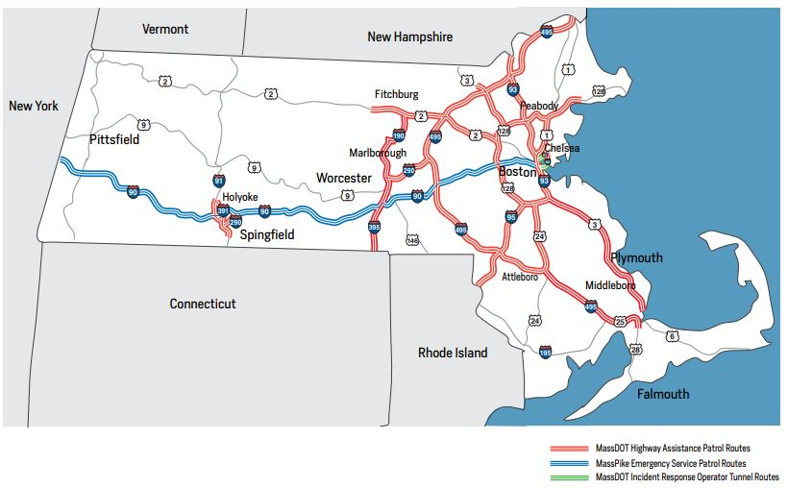

Highway Assistance Patrol (HAP)
MassDOT and its predecessor, the former Massachusetts Highway Department (MHD) has operated a Highway Assistance Patrol for over twenty years. The current Highway Assistance Patrol includes twenty-six (26) patrol routes covered by 22 vans and 4 ramp trucks, on 13 federal and state roadways throughout the Commonwealth. The purpose of the HAP is to mitigate the impacts of traffic congestion by providing immediate service to disabled vehicles and crashes encountered in patrol areas, identify and provide for rapid removal of abandoned motor vehicles in hazardous locations and safely removing debris. HAP Drivers coordinate with MassDOT’s Highway Operations Center (HOC) and the Massachusetts State Police (MSP) through direct radio communication. This is a contractor-based program, competitively procured every three years to the extent feasible. The current contract expires in February 2019 with new contract(s) expected to be in place by March 1, 2019. The program operates Monday through Friday, 6am-10am and 3pm-7pm on a spilt shift basis, with augmented coverage assignments during special events and holidays in routes with heavy traffic.

Emergency Service Patrol (ESP)
MassDOT and its predecessor, the former Massachusetts Turnpike Authority (MTA) has operated an Emergency Service Patrol (ESP) for over twenty years. The ESP consists of twenty (20) MassDOT employees assigned to cover Interstate 90 (I-90 or the Pike) across four (4) areas, with staffing 7 days a week, 24 hours a day to the extent feasible. ESP patrol trucks have no towing capability. The purpose of the ESP is to provide direct roadside assistance to patrons in need of support along I-90 from the New York border into Boston. The ESP mitigates the impacts of traffic congestion by providing immediate service to disabled vehicles and crashes encountered in patrol areas, and safely removing debris. ESP drivers coordinate with the Massachusetts State Police (MSP) through direct radio communication and with the MassDOT’s Highway Operations Center (HOC) on large-scale events.

Incident Response Operator (IRO)

MassDOT and its predecessor, the former Massachusetts Turnpike Authority (MTA) has operated an Incident Response Operator (IRO) program since incremental completion of the Central Artery Tunnel Project in 1995. These vehicles assigned to the I-93 O’Neill Tunnel, Tobin Bridge, Ted Williams Tunnel, Sumner and Callahan Tunnels, Zakim Bridge, and other MassDOT roadways within the Metropolitan Highway System, provide immediate roadside removal service for disabled vehicles or vehicles involved in a crash by safely relocating them from the critical roadways of the tunnel system. All of the IRO vehicles are ramp trucks with hoisting and towing capabilities. IRO Drivers are MassDOT Highway Division District 6 employees and coordinate their response efforts with MassDOT’s Highway Operations Center (HOC) and the Massachusetts State Police (MSP) through direct radio communication, 7 days a week on a 24-hour basis to the extent feasible. This program supports environmental mitigation efforts in an enclosed tunnel environment, promotes safe quick clearance and reduces the occurrence of secondary incidents by focusing on immediate vehicle removal rather than basic vehicle repair.

Highway Assistance Programs Fleet Overview
In total, the programs include the following number of vehicles. The HAP program currently utilizes at least 28 vans and 6 Flatbed ramp trucks. The ESP program currently utilizes at least 13 Ford F250 Trucks. The IRO program currently utilizes at least 10 Flatbed ramp trucks. There are currently a total of 57 vehicles in the programs’ fleet.

Scope of Sponsorship

The successful sponsor(s) of the programs will agree to provide a payment by check in US dollars of an agreed upon sponsorship fee. Payments will be made in equal installments on an annual basis with the first payment due upon the execution of the sponsorship agreement, and subsequent payments due on an annual basis thereafter throughout the term of the agreement, on the anniversary date of the agreement execution. MassDOT is requesting that interested parties submit a sponsorship fee proposal and a marketing package proposal envisioned to be afforded by MassDOT in exchange for the proposed annual sponsorship fee.
Official sponsorship of MassDOT’s Highway Assistance Patrol, the Emergency Service Patrol, and the Incident Response Operator programs should include a flat rate fee proposed for remittance to MassDOT on an annual basis. Marketing packages to be provided by MassDOT shall be included in the proposal and should reflect the potential sponsor’s minimum expectations for its return on the proposed sponsorship investment. The scope of the proposed marketing package should not be constrained or limited to previous or typical forms of exposure. Interested parties should propose the minimum level of marketing exposure desired as part of the sponsorship agreement.

At a minimum, MassDOT is prepared to accept marketing packages that include placement of the sponsor(s)’ logo, trademark, or business brand on all of the aforementioned vehicles in the program. Proposals should detail with sample vehicle drawings or augmented photographs depicting how branding placement demonstrates on the subject vehicles.

Selected sponsor(s) agree that MassDOT shall have final approval of all graphics associated with the sponsorship agreement, and that the sponsor shall, in addition to paying the annual sponsorship fee described above, agree to cover the cost of branding and wrapping the subject vehicles with the approved graphic at the outset and over the course of the agreement to ensure quality assurance.

MassDOT makes no commitments or assertions regarding the value on the return on investment for prospective sponsors of the programs. Emergency service delivery under the three programs is expected to yield significant sponsor branding exposure. MassDOT has not conducted a cost/benefit analysis relative to previous sponsorship agreements and has no data to provide regarding potential returns on investment acquired by prior sponsors. MassDOT also refrains from providing how the sponsorship fees support the programs’ operation or how those fees support other MassDOT functional costs.

Requirement of Non-Collusion

MassDOT will reject any or all proposals if there is any is reason to believe that there is or has been collusion among respondents in the development of proposals for the agreement. MassDOT reserves the right to require any Respondent(s) to sign a certificate of non-collusion.

Features of Current Sponsorship Agreement

MassDOT encourages interested parties to submit innovative and creative proposals for branding and marketing packages as part of the submission. MassDOT encourages interested parties to submit proposals that leverage the latest technologies and marketing strategies in providing private sector exposure for an established and scaled sponsorship fee. Current sponsorship features outlined below are for frame of reference only; they are neither discouraged nor encouraged through this RFP.

In addition to the minimum acceptance of marketing packages that include placement of the sponsor(s)’ logo, trademark, or business brand on all of the aforementioned vehicles, MassDOT will entertain and consider proposals for branding in other forms of the programs’ business operation. Current and previous agreement packages have included a branding presence on applicable contractor uniforms, roadway signage, website links and blogs, press releases, and special event appearances.

Other features of the current agreement include the sponsor’s management of an annual program report and a customer-service feedback-process. The sponsor receives program performance reports from MassDOT and generates an annual program performance report with the sponsor’s branding featured in a prominent placement. The sponsor also produces customer service paper cards provided to recipients of services, and patrons are encouraged to complete and return service evaluation through regular mail or through digital electronic applications. The sponsor receives these comment cards from patrons assisted and develops annual customer satisfaction reports within the overall program annual report.

MassDOT’s current sponsorship agreement is with MAPFRE Commerce Insurance and is currently set to expire on February 28, 2019. All of the aforementioned terms are part of this current agreement, and the annual fee is currently $1.2 million US dollars per year. MassDOT does not intend to provide samples of marketing and branding materials associated with its current or previous sponsorship agreements, and encourages interested parties to conduct independent research if so desired, and to develop proposals based on potential new approaches rather than on past practices.

Sponsor Branding and Approval
The selected sponsor will be responsible for all costs associated with the creation, production, installation, maintenance and safety requirements of all branding on the HAP/ESP/IRO vehicles at the start and over the course of the agreement, and any other features agreed to and provided by MassDOT throughout the term of the agreement. MassDOT will coordinate with the selected sponsor and other internal and external business units and stakeholders to review, approve, and schedule branding templates and deployments over the course of the agreement, including any changes in branding placement and size. All sponsor branding over the course of the agreement requires MassDOT approval in advance of installation or deployment, and MassDOT retains full and final discretion on branding application decisions.

Safety Restrictions
HAP, ESP, and IRO vehicles must comply with all MassDOT safety requirements, including vehicle markings, emergency lighting, and public-safety incident-management equipment. MassDOT will work with the selected sponsor regarding all necessary markings and branding placement to ensure branding compliance with applicable federal and state laws and regulations related to the safe operation of motor vehicles in general and emergency response vehicles specifically on public roadways.

- EVALUATION CRITERIA
Bidders need to propose for all three programs. The selected sponsor(s) will be the interested party submitting a proposal that demonstrates the best value for MassDOT in a sponsorship engagement that balances the prevailing program interest as a transportation public safety initiative with a corporate interest in sponsoring service delivery and deriving benefit from branding exposure associated with service delivery. The selected sponsors or sponsor will be an entity that can demonstrate a shared business interest in the public’s wellbeing on active roadways of the Commonwealth.

MassDOT will consider the business interest of the proposed sponsor, the approach, the proposed fee, minimum features anticipated as part of the fee, additional features offered, and proposed fees associated with additional features. MassDOT shall use a best value and best interest standard in selecting the successful sponsor. A selection team will review proposals, score and rank the proposals to determine a list of preferred sponsors. MassDOT may seek to engage preferred sponsors in further discussions through formal presentations, or may engage with the top ranked proposed sponsor for agreement negotiations. MassDOT may select one or more sponsors for each of the three programs. Execution of a final agreement will be contingent on agreement reached regarding the final scope and features of program sponsorship, the associated fee, and approval of all branding materials deployed under the agreement in all selected avenues of program operation.

Requirements Only Upon Award
There will be a signed agreement between MassDOT and the sponsor(s).

Prohibition Regarding Contract Terms

Bidders must not, as part of their bid Responses, propose additional contractual terms, or supplemental or clarifying language pertaining to contractual terms, even if the proposed additions/clarifications are not in conflict with the MassDOT Terms and Conditions, the MassDOT Standard Contract Form, or other documents comprising this RFP. MassDOT does not want and will not read, consider or evaluate a line by line response to this RFP.

- HOW TO SUBMIT A PROPOSAL
Email Bid Response Form to Tim.Morin@state.ma.us by dates outlined in Section 2 of this RFP.

OWNERSHIP OF SUBMITTED PROPOSALS
MassDOT shall be under no obligation to return any proposals or materials submitted by a Bidder in response to this RFP. All materials submitted by Bidders become the property of MassDOT and will not be returned to the Bidder. MassDOT reserves the right to use any ideas, concepts or configurations that are presented in a Bidder’s proposal, whether or not the proposal is selected for an agreement.

COSTS
MassDOT is not liable for any costs a Bidder incurs in responding to this RFP or from participating in the evaluation process, regardless of whether MassDOT enters into an agreement through this process, decides not to go forward with the sponsorship, cancels this RFP for any reason, or enters into an agreement through some other process or through another RFP.

PUBLIC RECORDS
All responses and information submitted in response to this RFP are subject to the Massachusetts Public Records Law, M.G.L., c. 66, s. 10, and to c. 4, s. 7, ss. 26. Any statements in submitted responses that are inconsistent with these statutes shall be disregarded.

